**Documentation of Code**

**1.Main Instruction for Use：**

**1.1 Parameter definition**

At the beginning of the code,you can set initial values for **the number of nodes**,**cost**,and **network density**.

Parameter **alpha**,**Beta** and **G** will be generated automatically (randomly).

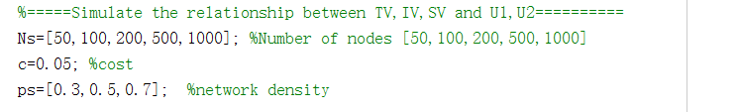

**1.2 Result review**

Note that all results are stored in **Matrix** form for easy reading.

In genNet_culTV2_Beta_N.m,**TVU1** stores Kendall tau of TV and U1,and **IVU2** stores Kendall tau of IV and U2.It is related to **Fig.5**.

In genNet_culTVB_Beta_N_match.m,**TVB** and **IVB** stores TV and IV before random match.**TVs** and **IVs** stores TV and IV after random match. It is related to **Fig.6**.

In genNet_culTVB_Beta_N.m,**TVU1** stores Kendall tau of TV and U1,and **IVU2** stores Kendall tau of IV and U2.It is related to **Fig.7**.

2.Procedure contents：

|  |  |
| --- | --- |
| **Main code** | |
| **genNet_culTV2_Beta_N.m** | Calculate Kendall tau of TV and U1,IV and U2 when fulfill all assumptions |
| **genNet_culTVB_Beta_N_match.m** | Calculate TV,IV for best match and random match, when assumption2 and assumption 3 are relaxed |
| **genNet_culTVB_Beta_N.m** | Calculate Kendall tau of TV and U1,IV and U2 with different c, when assumption2 and assumption 3 are relaxed |